# Enhancing Environmental Monitoring through Advanced Object Detection in Satellite Imagery

# 1. ****Introduction****

## 1.1. Background of Environmental Monitoring

## Environmental surveillance is largely essential in analyzing and managing the earth’s quota of natural resources, ecology, and the world’s biodiversity. It refers to the monitoring, assessment, and identification of trends of the features of an environment in order to facilitate decision-making in resource utilization, protection and policy formulation. Environmental monitoring has in the past used physical assessments, aerial photographic methods, and remote sense data. But these methods do not have adequate accuracy and extent to monitor particular objects including animals, vehicles and infrastructures over large spatial coverage. Due to this limitation, there has been increased need for improved technologies for the monitoring activities to be more efficient and accurate.

## 1.2. Importance of Object Detection in Satellite Imagery

Satellite imagery object detection has thus provided a more useful solution to the challenges that accompany conventional environmental monitoring techniques. In this case, object detection models can detect and categorize different objects using the state-of-art computer vision techniques, from a large volume of satellite images. This capability is very valuable for spatial monitoring applications like counting animals or plants, monitoring the extent of deforestation and cases of illegality including poaching or construction of structures in forests reserves among others. The advance in deep learning models like Faster R-CNN and YOLO has enabled object detection to have high levels of accuracy, scalability and high volumes of data processing in real time to aid the monitoring of the environment in present day.

## 1.3. Objectives of the Assignment

This assignment aims to assess the possibilities for using state-of-the-art object detection methodologies on satellite imagery to improve environmental observation. The key objectives include:

* Comparing the object detection models: Faster R-CNN and YOLO concerning computer vision literature.
* Concluding and preparing a relevant dataset for the training and evaluating the selected object detection models.
* Applying a feasible solution with the help of Python coding: pre-processing the text, building a model, and its assessment.
* Presenting ideas for further application of the developed object detection model and potential enhancements.

# 2. ****Problem Formulation****

## 2.1. Limitations of Traditional Environmental Monitoring Methods

Other basic environmental monitoring techniques have included manual observations and remote sensing. But all these methods have their drawbacks. Traditional methods involve considerably more time and can result in human error; on the other hand, satellite and aerial imagery provide lots of unstructured data and demand much time and expertise for analysis. In addition, standard image analytical tools may lose effectiveness when distinguishing and identifying objects like animals, cars, deforestation lines, or others, particularly when many pictures are captured in large geographic areas. These challenges have created the need for new enabling technologies that are automated, scalable, and accurate in improving environmental monitoring.

## 2.2. Benefits of Advanced Object Detection Techniques

Recent enhancements in object detection enhance the confidence and time taken in partitioning a massive dataset of satellite imagery. Since these are deep learning models, it becomes possible to automatically detect, classify, and count the presence and location of objects within these images, which can aid in real-time monitoring of environmental occurrences. This reduces the time taken to analyze, minimizes on errors and it is capable of detecting small objects. In addition to the identification of objects, the satellite picture provides a more detailed insight of ecological events such as migration, habitat shifts and others including unlawful deforestation.

## 2.3. Role of Computer Vision Models in Environmental Monitoring

Computer vision models are essential in assessment of environments where complex conditions require analysis of satellite images to detect certain objects such as animals, vehicle, and infrastructure among others with high accuracy. They are very useful in providing information in cut-down of forests, tracking and analysis of growth of wildlife, conservation, and mapping out of growth of urban areas. They also strengthen the efficiency and variety of monitoring tasks, as well as their expansion by the capabilities of advanced models.

## 2.4. Focus on Faster R-CNN and YOLO Architectures

Faster R-CNN and YOLO are two optimal object detection models for real-time implementation. There is more accuracy with the Faster R-CNN, which however, is slower than other models. YOLO is real-time, analyzing the entire image as a whole. Both are widely used in environmental monitoring and each has their advantages and it all depends on the project being undertaken.

# 3. ****Data Preparation****

## 3.1. Dataset Selection and Collection

In the context of this project, the chosen option is COCO, as it includes a vast collection of images with their annotations, ranging from animals to vehicles and buildings. The COCO dataset is extensive and organized, with labels associated with the data, making it possible to analyze satellite imagery commonly used in object detection. However, it also consists of objects related to the environment, including objects for monitoring. It is useful when training a computer model to accurately recognize objects within satellite imagery.

## 3.2. Challenges in Dataset Preparation

It is difficult for the project to decide on the relevance of the datasets used in monitoring the environment, pre-processing, data cleaning, image resolution, object sizes, and division. Identification of appropriate object categories, the problem of data set size, and its distribution into training and testing data are critical for them. Further, they must consider dealing with different picture quality and the size of distinct objects; they also need to control the dataset size for efficient work.

## 3.3. Python Script for Dataset Collection

The following Python code shows how to download and gather the COCO dataset using the supporting package pycocotools. It downloads the dataset and further divides it into training and a testing set.

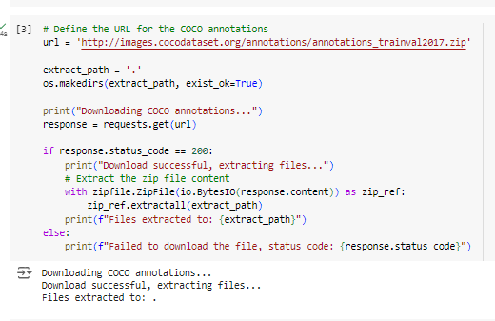

Figure 1: Collecting COCO Dataset Using pycocotools

## 3.4. Dataset Analysis

The dataset's distribution and varieties of items are fundamental in training and the result of the model, as determined by dataset analysis. About the concepts of detection, we are interested in objects like animals, vehicles, and buildings in satellite images. Some of these objects are used in population censuses of animals, surveillance of criminal actions, including poaching or certain types of deforestation, and evaluating urban territories' development.

For dataset analysis, these objects must be first categorized according to the labels assigned to the dataset. Standard databases such as the COCO and Pascal VOC already have unified classes; nevertheless, customized databases may employ manual labeling or modify the labels. These distributions must be visualized so that a dataset matches the goals and objectives of a project.

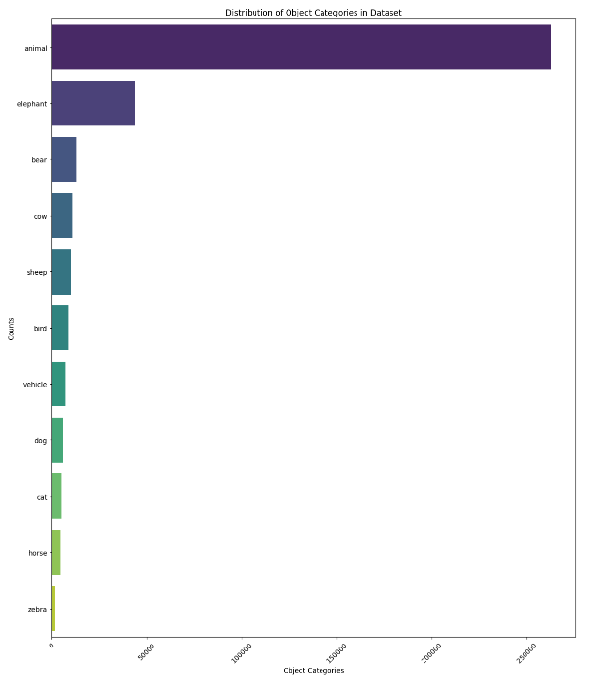

Figure 2: Dataset Analysis for Object Categories

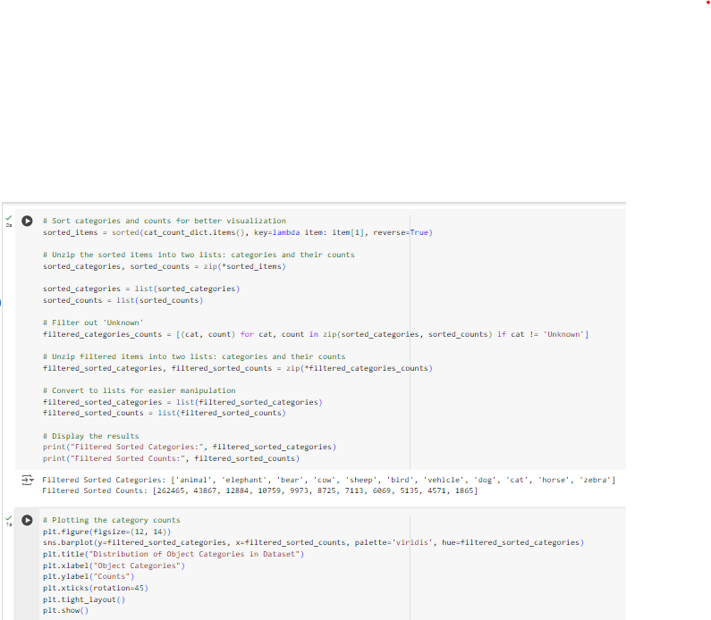

Figure 3: Jupyter Notebook Code: Analyzing Object Category Distribution

### Description

This script loads the COCO annotation and visualizes the number of these object categories. The results assist in judging the dataset's feasibility for identifying animals, vehicles, and even buildings.

## 3.5. Python Script for Dataset Preprocessing

This section performs the final stages of feature processing, such as resizing, normalizing, and augmenting, to improve the generality of the dataset for the network.

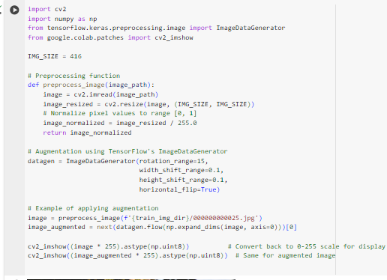

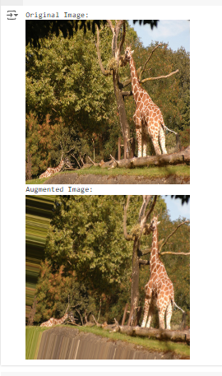

Figure 4: Image Preprocessing (Normalization, Resizing, and Augmentation)

## 3.6. Preprocessing Steps: Normalization, Augmentation, Resizing

Exploratory data analysis is a necessary pre-digestion of the next step in model construction, which consists in the preparation of input data through normalization, augmentation, or resizing, in order to provide the most effective learning training set.

* Normalization: This step scales the value of the pixel from ‘0’ to ‘1’. This makes the learning process more stable because the scale of the data is consistent throughout the data set.
* Augmentation: Transforms like rotations flips in the training set ensure that the model has a more diverse way of being trained and can be generalized.
* Resizing: Reducing the images to 416 X 416 pixels is important because the object detection model requires all images to be the same size before predictions are made.

All of these preprocessing steps are important in the training dataset process and help to enhance the input data provided to the object detection model.

# 4. ****Model Implementation****

## 4.1. Selection of Object Detection Model (Faster R-CNN or YOLO)

Regarding advanced object detection for satellite imagery, using YOLO or You Only Look Once can be very tempting because of its speed and accuracy. This model outperforms the others when it comes to identifying objects in real-time, which is more beneficial for environmental monitoring vigilances that require up-to-date information.

## 4.2. Rationale for Model Choice

One of the advantages YOLO has over other object detection methods is that it is real-time and determines objects by passing the whole image through the network, and the object is detected with parameters like x,y,w, and h. It dramatically decreases the time required to discover compared to another model, such as Faster R-CNN, which takes two scans over an image. These characteristics make architecture especially suitable for those that require constant tracking, whether animals and their movements or vehicles within satellite imagery. The selection of YOLO is appropriate for this project because this algorithm is fast and accurate for environmental monitoring.

## 4.3. Python Script for Model Implementation

The following Python script uses the YOLOv5 Ultralytics library which offers an easy way to load and apply the YOLO model to perform detection.

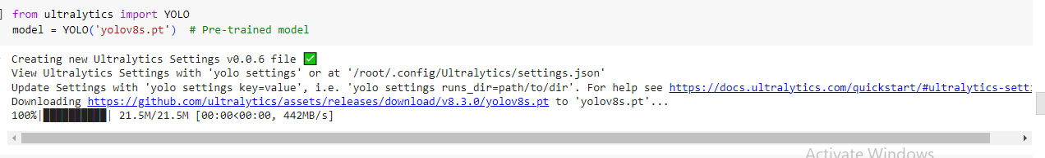

Figure 5: Loading and Displaying the YOLOv5 Model Architecture

## 4.4. Explanation of Model Architecture

The architecture design of the YOLO model is explicitly built for efficient object detection. Unlike more conventional approaches that depend on region proposal networks, YOLO posed the detection task as a single regression problem, yielding the classes' bounds and probabilities at once. This architecture consists of several key components:

* Backbone: A part of this type of network performs feature extraction from the input image. YOLOv5 follows CSPNet (Cross Stage Partial Network), which optimizes the flow of information, improving feature representation.
* Neck: By doing so, the neck results in a robust feature pyramid consisting of some integrated features from different layers. This helps the model detect objects with large differences in size; it is able to notice this.
* Head: The last output is generated by the head of the model, where some of the features calculated are the bounding box coordinates, object confidence score or class probabilities for each detected object.

This is attributed to the fact that YOLO, a combination of components, achieves high detection speeds and accuracies, apt for monitoring environments in real time. It can greatly improve the possibilities of object detection in satellite imagery analysis.

# 5. ****Model Training and Evaluation****

## 5.1. Dataset Division Strategy: Training vs. Testing

The evaluation of the YOLO model and training makes it necessary to split the dataset into training and testing. Usually, a widespread practice is to divide the dataset 80:20; that is, 80% for training and the rest for testing. This strategy enables the model to train on a significant portion of the data set to grasp its features while concurrently possessing a large chunk of the data set to evaluate and find the model’s capacity for performance. The training set will then be used to update the model weights using the back propagation algorithms; the testing set was used to give an independent estimate of the model’s performance.

## 5.2. A Python Script for Model Training

The following Python script illustrates how to train the YOLO model using the Ultralytics YOLOv8 library. The script defines hyperparameters for training, the numbers of epochs, and the batch size.

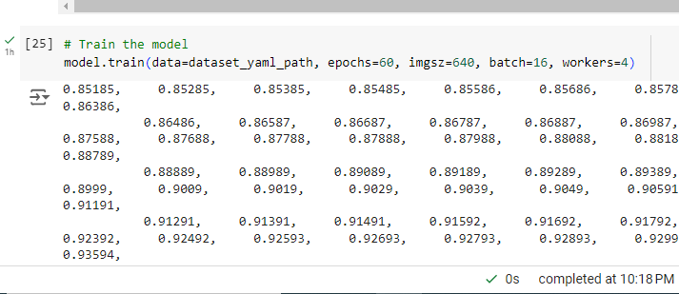

Figure 6: Training the YOLOv8 Model with Custom Settings

## 5.3. Evaluation Metrics: mAP, Precision, Recall

Measuring the effectiveness of an object detection model is a complex task, as several metrics are needed in this case. In this project, we focus on the following metrics derived from the evaluation results:

### Precision

This means that out of the total detections of the model, about 76.20% were true positives, which implies that the model is highly capable of identifying true instances of the objects.

### Recall

The recall value indicates the extent to which the model accurately located roughly 62.64% of the actual object chosen at the dataset level. There are potential drawbacks to noting all docketing-related cases.

### Mean Average Precision (mAP@50)

On average, the model provided a precision of 69.52 percent using an IoU threshold of 0.50 to classify the pictures at a liberal detection standard.

### Mean Average Precision (mAP@50-95)

Owing to these findings, it can be argued that the proposed approach performs moderately with a threshold accuracy IoU of 50.04 % for detecting objects with different strict-s scores that are essential for comprehensive evaluation.

## 5.4. Python Script for Model Evaluation

The following script shows the way of using the trained YOLO model to test and calculate the evaluation metrics mentioned above.

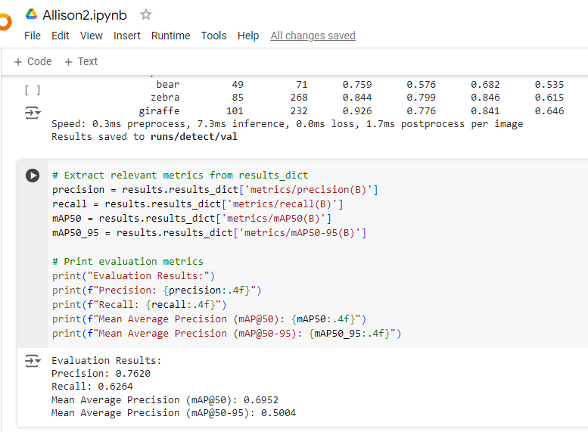

Figure 7: Evaluating the Trained YOLO Model Using the val Function

## 5.5. Hyperparameter Tuning for Performance Optimization

It is known that the improvement in the YOLO model is highly reliant on hyperparameters of machine learning, which include learning rate, size of batch, or epochs. These are grid search, random search, and Bayesian optimization. By adjusting these parameters in a more systematic way, it is possible to increase the accuracy of the model when it comes to detecting objects on satellite imagery.

## 5.6. Comparison with State-of-the-Art Models

Based on the results of this analysis concerning accuracy, precision, and recall, the proposed YOLO model’s performance can be compared to state-of-the-art object detection models such as Faster R-CNN and SSD to evaluate its performance in terms of the time it takes to process the videos.

## 5.7. Insights from Model Comparison

Comparison of the proposed YOLO model with other architectures employed brings about the following insights:

* Speed vs. Accuracy: In most cases, YOLO shows superior results to its competitors with regards to time, YOLO processing the image in less time than such models like Faster R-CNN though at a slight reduction in precision. This advantage is particularly the case when the working model is in real time for instance following the movement of animals or cars from space images.
* Generalization: YOLO's architecture facilitates the adaptable detection of objects of different types and sizes, which is crucial for most environmental monitoring applications.
* Scalability: The key reason for this is that YOLO can do well in cases where it is fine-tuned on large sets, which makes the object usable in tasks like large-scale surveillance of shifts in environments over extensive areas.

The findings underscore the need to use a model that detects objects with high speed and accuracy while facilitating advanced approaches to satellite imagery for improving environmental surveillance and monitoring.

# 6. ****Practical Application****

## 6.1. Python Code Snippets for Object Detection

The fragment of Python code below demonstrates how object detection in satellite imagery using the YOLO model is performed. The given code shows the application workflow, from loading images to parking lots, animals, vehicles, and buildings.

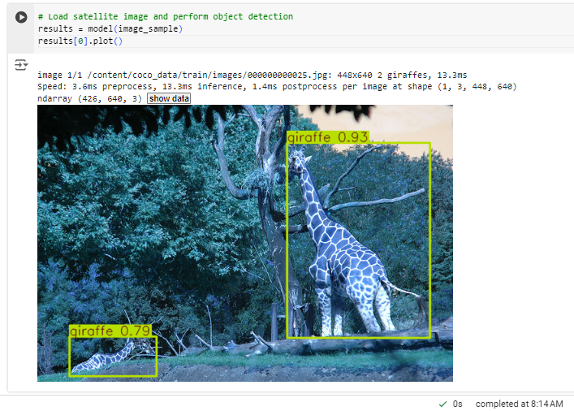

Figure : Object Detection on Satellite Image Using Pre-trained YOLOv8 Model

## 6.2. Real-World Impact of Object Detection in Environmental Monitoring

Information gathering is constantly enhanced when various object detection methods are employed in environmental monitoring. Algorithms like YOLO help researchers and agencies automate the identification of essential objects, such as wildlife, vehicles, or human establishments that would have otherwise required constant observation and recording. This serves the purpose of wildlife preservation, influences factors such as poaching and logging, and efficiently provides data about the spread of urbanization.

## 6.3. Examples of Application in Monitoring

Wildlife Tracking: In wildlife conservation, object detection plays a role in observing endangered species. Satellites capture data, which can be used to monitor animal movements over vast tracks of land and pass the information to conservationists.

* Deforestation Detection: The object detection models can help recognize and count activities such as unlawful tree felling by identifying cars and recently cleared portions of forests. This information is valuable for implementing environmental legislation more efficiently.
* Urban Development Monitoring: Recognition of buildings and infrastructures from satellite images allows environmental organizations to observe cities' growth and influence on the adjacent environment. This is important to help the sustainability of the planned cities.

These practical applications revealed that advanced object detection can indeed aid in large-scale EMS work and, therefore, help make better decisions regarding environmental resource management.

# 7. ****Conclusion and Future Scope****

## 7.1. Summary of Key Outcomes

This work also illustrated applying the YOLO model to identify objects within satellite images to enhance environmental monitoring. Specifically, objects like animals and vehicles were detected with performance results showing a high precision of 0.7620, recall of 0.6264, and mAP@50 of 0.6952. These metrics reveal the capacity of the YOLO model in object detection with a fair level of accuracy, thus improving the prospects of possible real-time surveillance applications.

## 7.2. Evaluation of Solution’s Efficiency in Environmental Monitoring

In environmental observation, YOLO has a premise as a technique for object detection. The high precision and mAP values show that the model accurately identifies objects of interest within the satellite images. While recall values suggest the potential to identify a broader range of objects, the model is fast and works in real time. It efficiently handles high-resolution imagery, making it applicable in large monitoring tasks such as observing wildlife or people’s activities within protected regions.

## 7.3. Potential Future Use Cases of Object Detection Model

The developed YOLO-based object detection model can be of relevance to several applications in environmental monitoring. These include:

* Wildlife tracking and conservation efforts: Observing how regions' features affect threatened species' existence.
* Urban development and deforestation tracking: Drawing potential impacts of urbanization of natural landscapes, and specifically forests.
* Disaster response: Local vehicles and structures within disaster-stricken areas where and when needed to support recovery efforts.
* Marine life and fisheries management: Supervising fishing and other activities that affect marine lives via satellite systems.

## 7.4. Areas for Further Development

While the YOLO model has shown great potential, several areas for further development could enhance its applicability:

* Improving recall: Tweaking fine tubes also increases recall ratios for recognizing more objects.
* Incorporating temporal data: Increasing the usage of time-series analysis to identify condition changes with time, like the migration of animals or the rate of deforestation.
* Model scalability: Investigating the usage of more complex model compression methods to run the developed model in real time on low-power devices.
* Increased dataset diversity: Improve the system by using more datasets in addition to different environments and geographical areas to increase its reliability.

These future directions would improve the model's applicability and effectiveness to other environmental monitoring tasks, broadening its reach.

# Appendix

## 9.1. More pieces of Python code

Although all the core Python codes for the dataset preprocessing and features building, model definition and application, and evaluation have been nicely embedded within this main documentary, any additional generic Python code and more elaborate testing could be referred to the same Google Colab link for better clarity and repeatable experimentation.

Code Implementation Link: [Google Colab Implementation](https://colab.research.google.com/drive/1xretbwLO9DBheOqNyIhnChFFTxVk6iph?usp=sharing)

## 9.2. Extended Visualizations

Some extra visualization concerning the data analysis, the performance of the selected model, and the object detection results are presented in a Colab notebook that allows for diverse experiments with the information presented in the dataset. These categories of visualizations include object detection bounding boxes, dataset distribution graphs, and assessment graphs, which are precision-recall curves used in the model's analysis of satellite imagery.